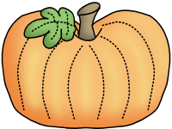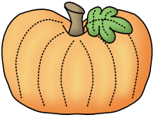

Thank you to the Booten Family for putting together our new Diner/Kitchen playset for the 50th day of school! The kids are going to have a blast from the past!

**Savvas Reading-** **Unit 1 Week 6**

***Research Based Inquiry:***

Art vs. History Museum

***Word Families:*** an, at, in, ip

***Letter Recognition & Sounds:***

Bb and Rr

***Sight Words:***

she, see, look

***Language and Conventions:***

Singular and Plural Nouns

**Math- *Chapter 4:***

***Count and Represent Numbers Through 9***

The Chapter 4 Test will be **Tuesday, October the 24th**. I am sending home the review practice test today so you can see how your child did. Please review at home tonight.

**Science-**

Nocturnal Animals

**10/23**

**Boosterton Kick-Off!**

**10/23-11/3**

Boosterthon Fun Run Collections

**Wednesday, 10/25**

50th Day of School (Dress in 50’s style wear!)

**Tuesday, 10/31**

Fall Party and Favorite Book Character Dress Up Day

**Friday, 11/3** Boosterthon Fun Run!

**Friday, 11/10**

Veterans’ Day Holiday (no school)

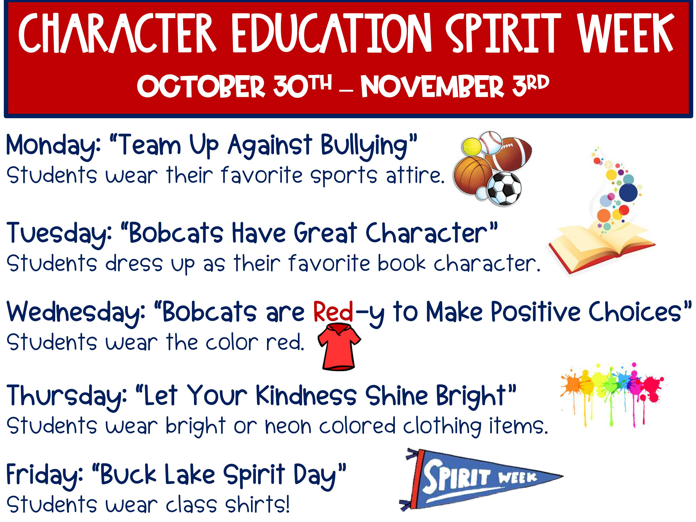

**Sonja Darden’s Kindergarten Class**

**Buck Lake Elementary** 488-6133 [dardens@leonschools.net](mailto:dardens@leonschools.net)

**October 23, 2023**

